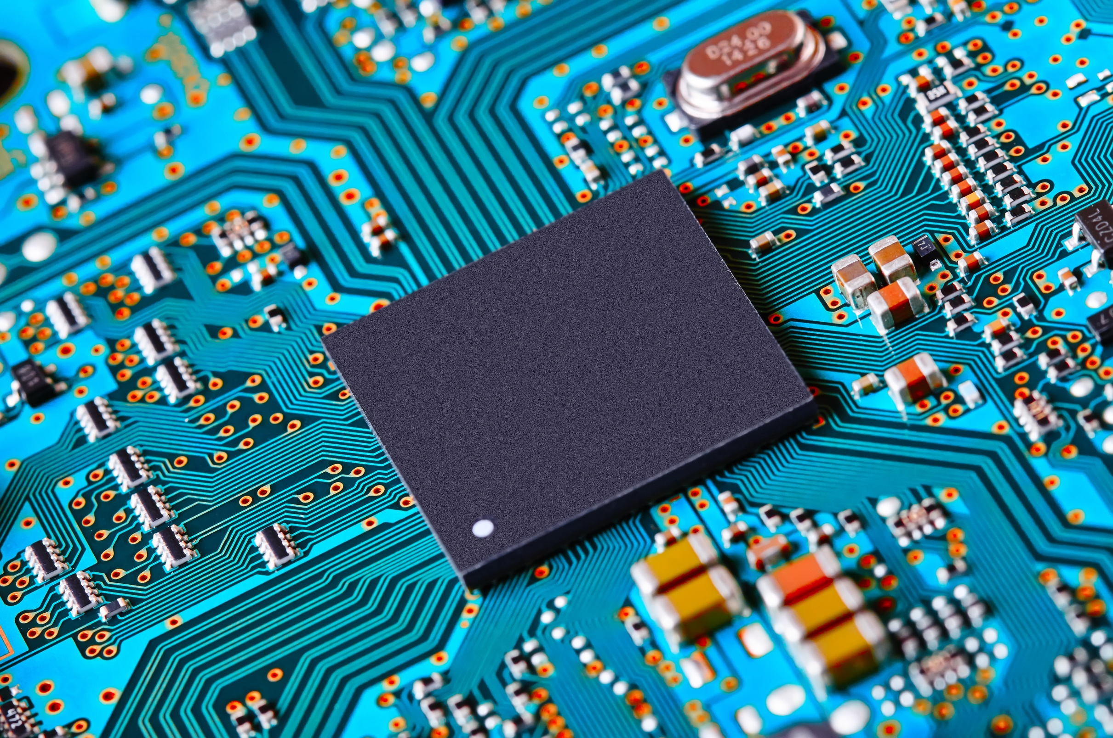

|  |
| --- |
| USB KEYBOARD INTERFACE |
|  |
| USB hid interface for the ucom  10103  Authored by: Jonathan Nock |

Notes: